Exercise 7: Return Data from a Scalar Function
CREATE DATABASE EmployeeDB;
GO
USE EmployeeDB;
GO
CREATE TABLE Employees
(
EmployeeID INT PRIMARY KEY,
EmployeeName VARCHAR(50),
Department VARCHAR(30),
Salary DECIMAL(10,2)
);
INSERT INTO Employees VALUES
(101,'Rahul','HR',35000.00),
(102,'Sneha','IT',50000.00),
(103,'Arjun','Finance',45000.00),
(104,'Priya','IT',60000.00),
(105,'Kiran','HR',40000.00);

SELECT * FROM Employees;

--Create Scalar Function
CREATE FUNCTION fn_GetSalary
( @EmployeeID INT )
RETURNS DECIMAL(10,2)
AS
BEGIN
DECLARE @Salary DECIMAL(10,2);
SELECT @Salary = Salary
FROM Employees
WHERE EmployeeID = @EmployeeID;
RETURN @Salary;
END;
GO
--Execute the Scalar Function
SELECT dbo.fn_GetSalary(102) AS EmployeeSalary;
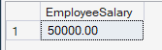
--Execute the Scalar Function
SELECT dbo.fn_GetSalary(104) AS EmployeeSalary;
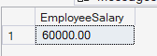
--Display Salary for All Employees Using the Function
SELECT
EmployeeID,
EmployeeName,
dbo.fn_GetSalary(EmployeeID) AS Salary
FROM Employees;
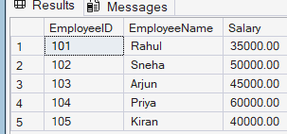

SELECT
EmployeeID,
EmployeeName,
Department,
dbo.fn_GetSalary(EmployeeID) AS Salary
FROM Employees;
